Chapter 10 Demos – Inheritance, Polymorphism & Interfaces
Oct 20, 2026 · @Jim Kaufmann

Overview
Four in-class demos teach the same Chapter 10 ideas as Labs 1–4 using different scenarios, so students see the techniques without seeing the lab answers. Each demo is a little smaller than its matching lab.
Demo | Scenario | Mirrors | Main idea
Demo 1 | Parcel Shipping | Lab 1 Letters | One subclass, virtual/override, a base-type List
Demo 2 | Pizza Shop | Lab 2 Photos | Two subclasses, enums, overridden ToString()
Demo 3 | Treasure Chest | Lab 3 BoosterPack | Interface, random generation, IComparable sort
Demo 4 | Campus Meal Card | Lab 4 BankLoginEnhanced | Multi-level inheritance, login, per-tier perks
Setup (all demos)
- Framework: .NET 10, Windows Forms, C# 14 (<TargetFramework>net10.0-windows</TargetFramework>).
- Create each project in Visual Studio 2026 with the Windows Forms App template, or from a terminal: dotnet new winforms -n Demo1 -f net10.0.
- Save in the repo under /Demos/CH10/ and name the projects Demo1, Demo2, Demo3, Demo4.
- Put each class, interface and enum in its own .cs file named after it.
- Money uses decimal and is shown with ToString("C").
- Classes must match the UML diagram for each demo: same names, fields, constructors, methods and properties.
Reading the UML
Symbol | Meaning
+ / - / # | public / private / protected
«virtual» / «override» | can be overridden / replaces the base version
{ get } / { get, set } | read-only property / read-write property
Hollow triangle arrow | inherits from (class) or implements (interface)
Hollow diamond | aggregation: the class holds a value of that type
Boxes have three compartments, as in the lab diagrams: fields, then constructors and methods, then properties.

Demo 1 – Parcel Shipping
A shipping counter app where a parcel with an insurance code becomes an InsuredParcel, and both kinds live in one List<Parcel>.
Requirements
- A standard parcel costs $4.00 to ship.
- An insured parcel costs an additional $2.50 and includes an insurance code.
- The user enters a recipient, a ship date and an optional insurance code, then clicks Ship.
- If the insurance code is blank, instantiate a Parcel object.
- If the insurance code is filled in, instantiate an InsuredParcel object.
- Store every parcel in a single List<Parcel>. The user can ship up to 10 parcels; after that, show a message and ship nothing.
- Add each parcel to the bottom of the shipment log, using the parcel's ToString().
- Show a running total of all shipping charges by adding up each parcel's Price.
- Recipient is required; show a message if it is blank.
Form controls
Control | Name | Purpose
TextBox | txtRecipient | Recipient name
DateTimePicker | dtpShipDate | Ship date
TextBox | txtInsuranceCode | Optional; filled in = insured
Button | btnShip | Create and store the parcel
ListBox | lstLog | Shipment log
Label | lblTotal | Total charges, e.g. Total: $14.50
Sample log
10/20/2026, Ranken Bookstore, $4.00
10/20/2026, Student Services, $6.50, Insured: INS-2041
10/21/2026, IT Help Desk, $4.00
UML
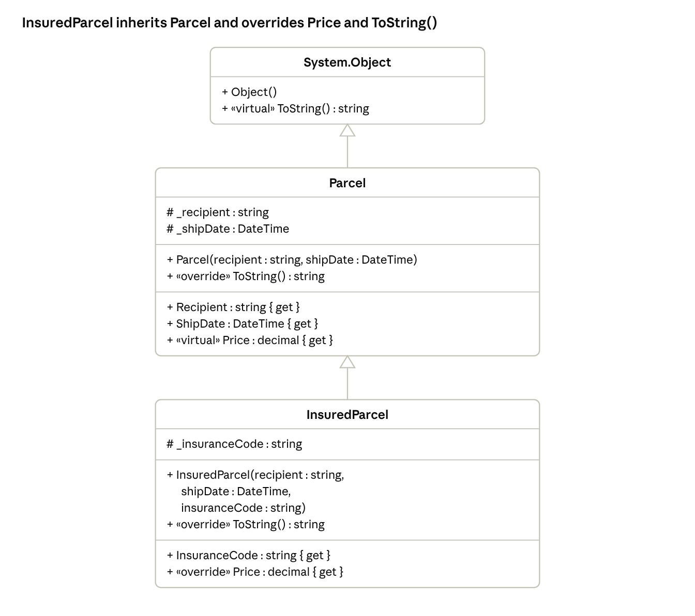
Demo 1 UML · Object → Parcel → InsuredParcel
Demo talking points
- InsuredParcel calls the base constructor with : base(recipient, shipDate).
- Price is virtual in Parcel; InsuredParcel overrides it as base.Price + 2.50m.
- The total loop calls parcel.Price on a Parcel reference and still gets $6.50 for insured parcels: that is polymorphism.

Demo 2 – Pizza Shop
A pizza pricing app with one base class and two subclasses, each subclass holding one enum choice.
Requirements
- Price by size (diameter in inches): 10" is $8.99, 14" is $12.99, any other size is $15.99.
- The customer picks one crust: Regular, Stuffed Crust or Deep Dish.
- Stuffed Crust adds $2.00 and needs a cheese choice: Mozzarella, Cheddar or Pepper Jack.
- Deep Dish adds $3.50 and needs a sauce choice: Marinara, Alfredo or BBQ.
- Enable only the GroupBox that matches the selected crust (cheese for Stuffed Crust, sauce for Deep Dish).
- On Calculate, instantiate the matching class into a single Pizza variable, then show its Price and its ToString().
- Override ToString() in Pizza, StuffedCrustPizza and DeepDishPizza so each shows all of its field values.
- Validate the size with int.TryParse; it must be greater than 0.
Form controls
Control | Name | Purpose
TextBox | txtSize | Diameter in inches
RadioButtons | radRegular, radStuffed, radDeepDish | Crust choice
GroupBox + RadioButtons | grpCheese | Mozzarella, Cheddar, Pepper Jack
GroupBox + RadioButtons | grpSauce | Marinara, Alfredo, BBQ
Button | btnCalculate | Build the pizza object
Label | lblCost | e.g. Cost: $14.99
Label | lblDescription | Output of ToString()
Sample output
14" Pizza Cost: $12.99
14" Stuffed Crust Pizza (CHEDDAR) Cost: $14.99
12" Deep Dish Pizza (BBQ) Cost: $19.49
UML
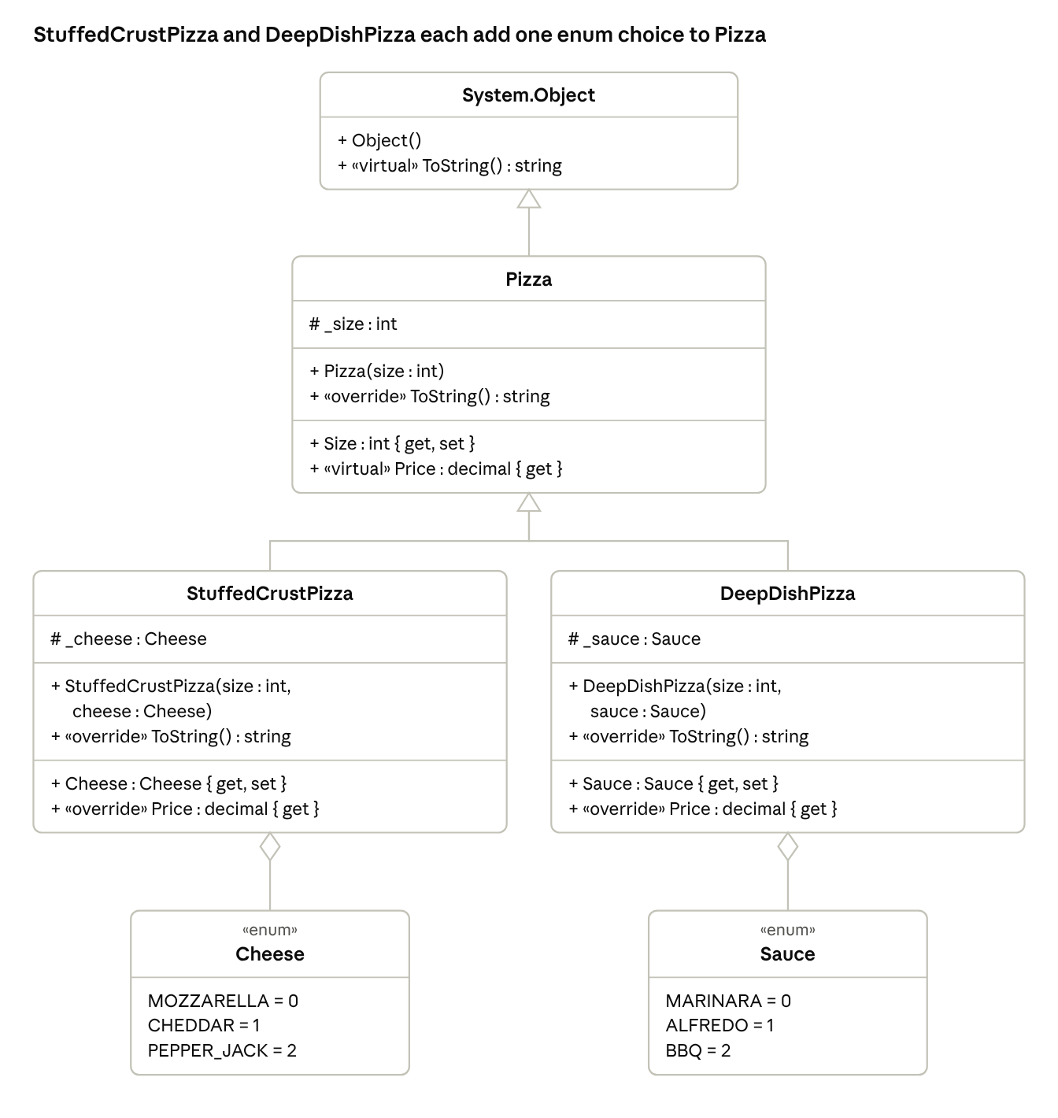
Demo 2 UML · Pizza with two subclasses and two enums
Demo talking points
- Both subclasses override Price as base.Price + <extra>; the size rules live only in Pizza.
- Each enum is held by one class (aggregation): StuffedCrustPizza has a Cheese, DeepDishPizza has a Sauce.
- lblDescription.Text = pizza.ToString(); runs the right override for whichever object was created.

Demo 3 – Treasure Chest
A random loot app where common and rare treasures share one interface, display themselves differently, and sort by value with IComparable. It uses Labels only (no images) to stay simpler than Lab 3.
Requirements
- Each click of Open Chest creates a new chest of 5 treasures, picked at random from the catalog below.
- Each treasure has a 25% chance of being rare.
- A rare treasure is worth 3 times its catalog value.
- Rare treasures display with a different font style, foreground color and background color than common ones (for example: bold, gold text on a dark background).
- Store the chest in a single List<ITreasure>.
- Sort the chest from highest to lowest value with chest.Sort(), using IComparable<ITreasure>.
- Each treasure shows itself in one of 5 Labels by calling its own ShowTreasure(label) method.
- Show the total value of the chest.
- Use one Random object for the whole form, not a new one per click.
Treasure catalog
Name | Catalog value
Copper Coin | $1.00
Silver Ring | $15.00
Pearl | $25.00
Ruby | $40.00
Ancient Map | $60.00
Gold Bar | $100.00
Form controls
Control | Name | Purpose
Button | btnOpenChest | Generate, sort and show a new chest
Labels | lblSlot1 … lblSlot5 | One treasure each, AutoSize = false so the back color shows
Label | lblTotal | e.g. Chest value: $261.00
Sample chest (sorted)
★ Ruby (Rare) $120.00 <- bold, gold on dark
Gold Bar $100.00
Pearl $25.00
Silver Ring $15.00
Copper Coin $1.00
UML
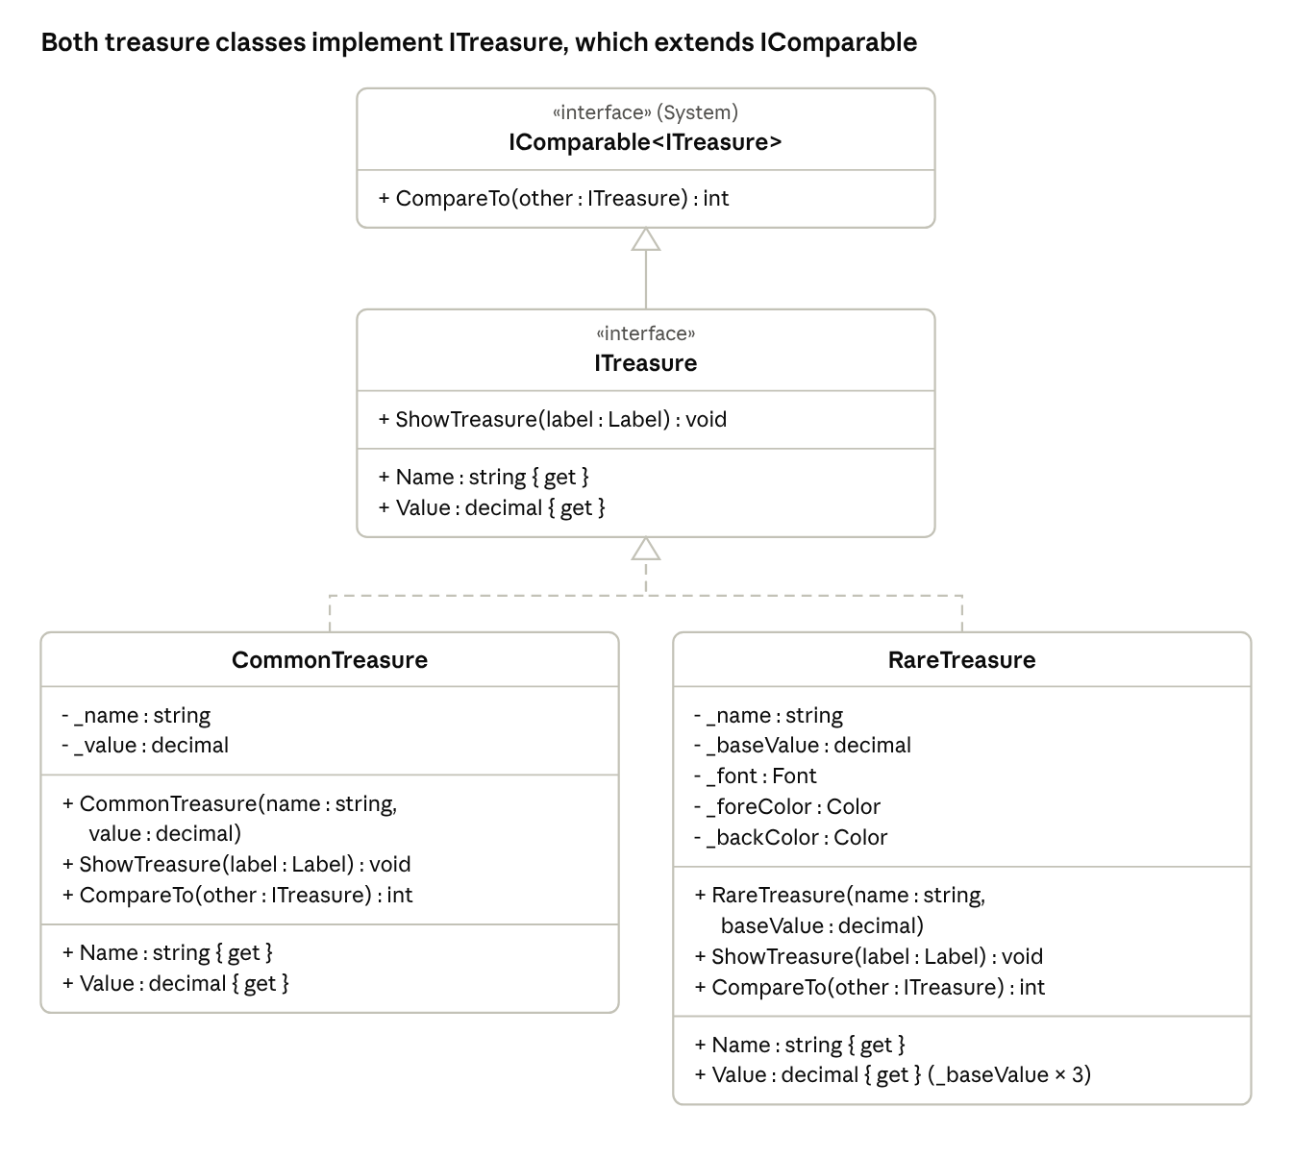
Demo 3 UML · dashed lines = implements an interface
Demo talking points
- The form never checks which class it has; it calls treasure.ShowTreasure(label) and each class decides how it looks.
- CompareTo returns other.Value.CompareTo(Value) to sort highest first; swap the two sides to sort lowest first.
- ITreasure extends IComparable<ITreasure>, so every treasure is guaranteed to be sortable.

Demo 4 – Campus Meal Card
A student meal-card app with login, three card tiers in a multi-level inheritance chain, a per-tier fee, and a second form for transaction history. It drops Lab 4's minimum-balance rules to stay simpler.
Requirements
- Users log in with a Student ID and a 4-digit PIN.
- Create the 3 cards below in the form's constructor and store them in a single List<MealCard>.
- Only one card can be logged in at a time. Until login, every control except the login controls is disabled.
- After login, show the owner's name, balance and card tier.
- Add Funds adds money with no fee.
- Purchase subtracts the amount plus a 2% convenience fee.
- A purchase that would take the balance below $0.00 is refused with a message.
- Record every transaction as one line of text, e.g. ADD $20.00 or PURCHASE $8.50 (fee $0.17).
- Log Out clears the screen and returns to the login state.
- The three tiers have different perks:
  - Basic: view balance, add funds, purchase.
  - Plus: everything in Basic, and View History shows the last 5 transactions in a separate window.
  - Premium: everything in Plus, pays no convenience fee, and the history window shows a receipt-style statement with a header and the current balance.
- Show the View History button only when the logged-in card's CanViewHistory is true.
Starting cards
Student ID | PIN | Name | Class | Starting balance
1001 | 1111 | Ava Lopez | MealCard (Basic) | $25.00
1002 | 2222 | Ben Carter | PlusMealCard | $50.00
1003 | 3333 | Chloe Nguyen | PremiumMealCard | $100.00
Forms and controls
Form | Controls
MainForm | txtStudentId, txtPin, btnLogin, lblWelcome, lblBalance, lblTier, txtAmount, btnAddFunds, btnPurchase, btnViewHistory, btnLogout
HistoryForm | lstHistory; its constructor takes List<string> lines and fills the ListBox
Sample history (Premium)
===== RANKEN MEAL CARD STATEMENT =====
Chloe Nguyen | Premium
ADD $20.00
PURCHASE $8.50 (fee $0.00)
PURCHASE $6.25 (fee $0.00)
Current balance: $105.25
======================================
UML
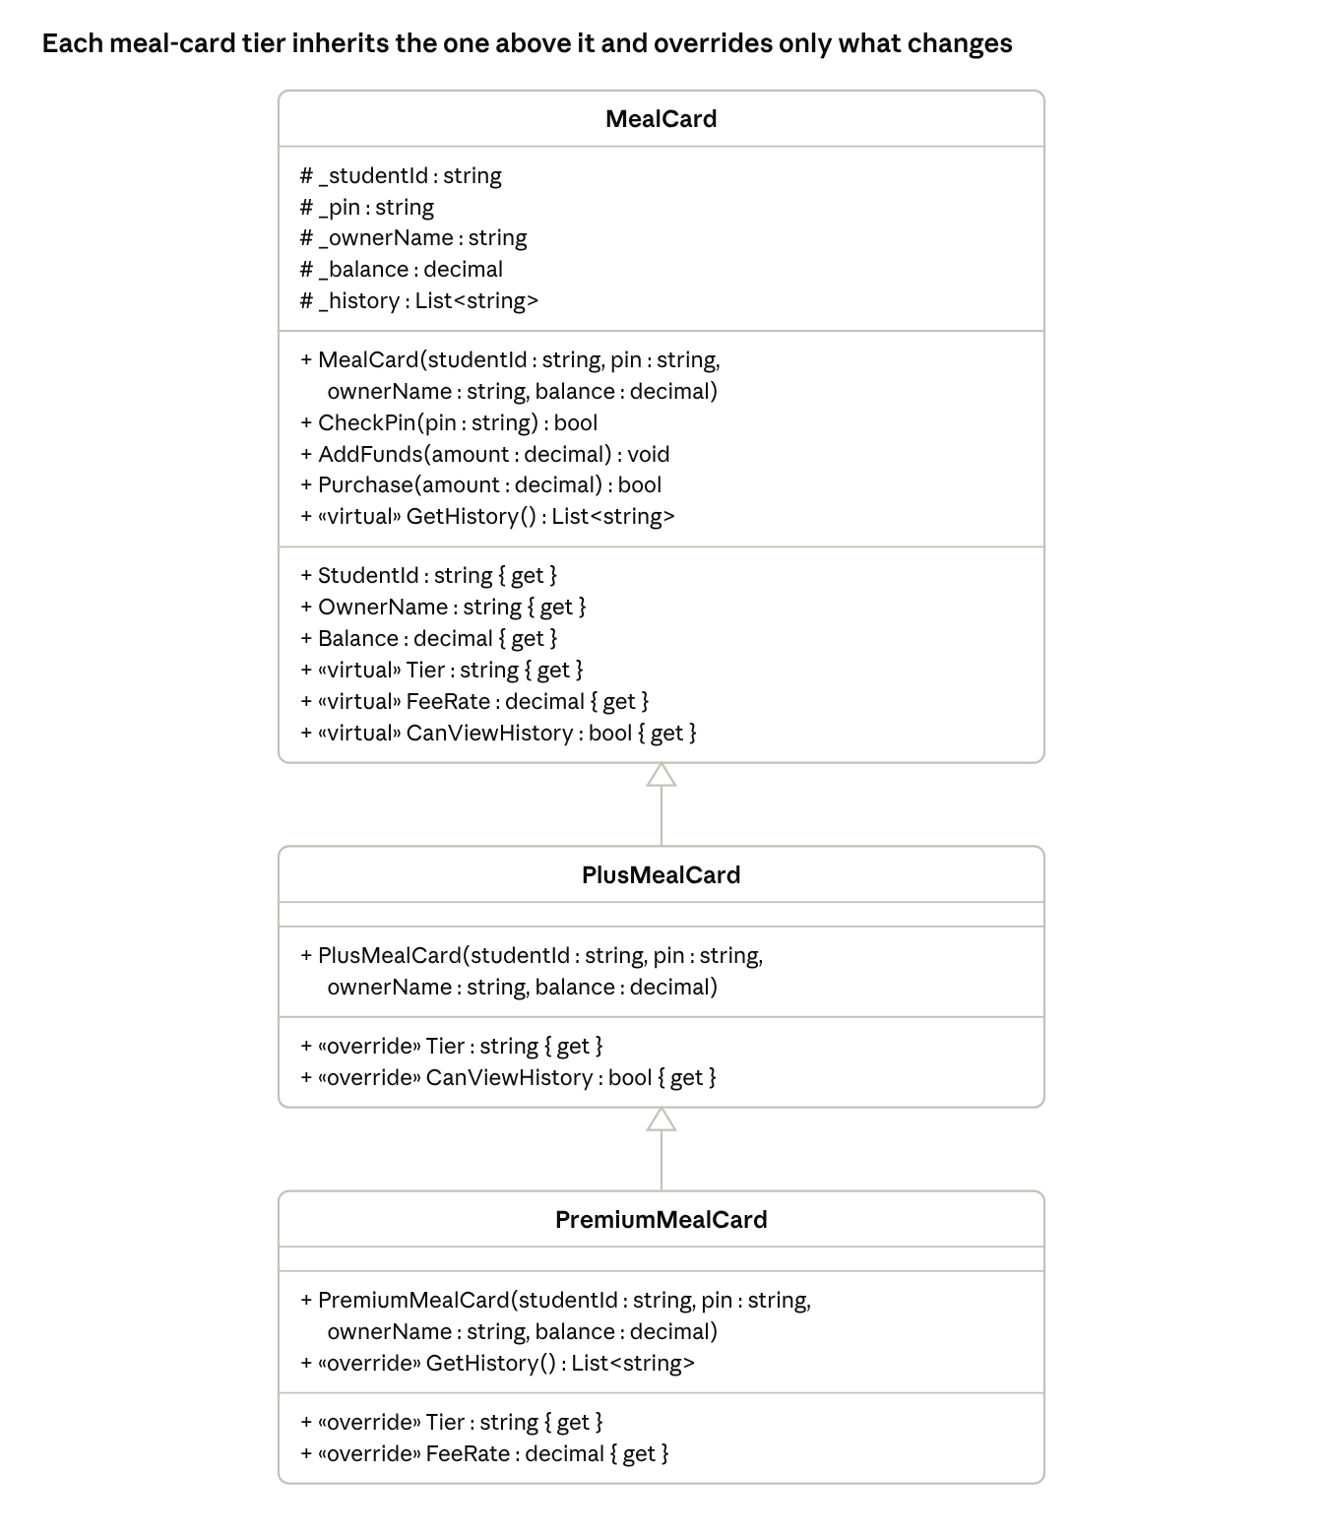
Demo 4 UML · MealCard → PlusMealCard → PremiumMealCard
Base values: Tier returns "Basic", FeeRate returns 0.02m, CanViewHistory returns false, and GetHistory() returns the last 5 entries of _history.
Demo talking points
- Purchase() is written once in MealCard but reads the virtual FeeRate, so a Premium card pays $0 without its own Purchase().
- PremiumMealCard inherits from PlusMealCard, so it gets CanViewHistory = true for free (multi-level inheritance).
- PremiumMealCard.GetHistory() calls base.GetHistory() and wraps the result with a header and footer.
- The logged-in card is held in one MealCard? _current field; null means nobody is logged in.

Concept map
Every bolded term from the Chapter 10 review list appears in at least one demo except abstract classes/methods and the strategy pattern, which the labs don't require either.
Term | Demo 1 | Demo 2 | Demo 3 | Demo 4
Inheritance, base class, subclass | ✓ | ✓ |  | ✓
Multi-level inheritance |  |  |  | ✓
Virtual and overridden methods/properties | ✓ | ✓ |  | ✓
Overridden ToString() | ✓ | ✓
base(...) constructor and base. member calls | ✓ | ✓ |  | ✓
Polymorphism through a base-type variable or list | ✓ | ✓ | ✓ | ✓
Protected fields (#) | ✓ | ✓ |  | ✓
Enums and aggregation |  | ✓
Interface |  |  | ✓
IComparable and sorting |  |  | ✓
Encapsulation (private fields, get-only properties) | ✓ | ✓ | ✓ | ✓
Second form |  |  |  | ✓

